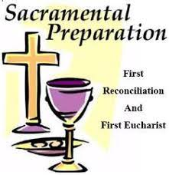
Our Lady of the Airways Church
First Confession/First Communion
Preparatory Sessions and Other Events Schedule 2023-2024

Preparatory Sessions start at 10:00am and end at 11:30am

DESCRIPTION OF EVENT | DAY-DATE AND TIME
Parents Meeting and Holy Mass | Tuesday, September 19, 2023 at 7:00-8:30pm
Registration and Holy Mass | Wednesday, October 25, 2023 at 7:00-8:30pm
Session 1 | Saturday, October 28, 2023 - 10:00 -11:30am
Session 2 | Saturday, November 11, 2023 -10:11:30am
Session 3 | Saturday, December 9, 2023 - 10:00 -11:30am
Session 4 | Saturday, January 20, 2024 -10:00 -11:30am
Session 5 | Saturday, February 3, 2024 -10:00 -11:30am
Session 6 | Saturday, February 24,2024 - 10:00 -11:30am
Session 7 | Saturday, March 23,2024 - 10:00 -11:30am
Session 8 | Saturday, April 6,2024 - 10:00 -11:30am
First Confession with parents/guardians | Saturday, April 20, 2024 -10:00 -11:30am
First Holy Communion Celebration | Saturday, April 27-2024 - 11:00am-12:30pm

Dear Parents/Guardians, please note:
It is very important that Candidates arrive at least 5 minutes before
the start of the session at 10:00 am, and must attend to all Preparatory
sessions in order to receive their First Holy Communion.
For more information, please contact the Sacramental Preparation Coordinator
at 647-978-6513 or olasacramentalpreparation20@gmail.com

